|  |  |
| --- | --- |
| **Developer Guide**  **Inquest**  **Faculty** = Miss Sana Sheeraz  **Coordinator**= Miss Fariha Alam  **Batch code** = 1807B1  **Curriculum**= 6673,  **Semester**= HDSE II,  C:\Users\asp\Desktop\123.png  APTECH North NAZIMABAD  http://www.aptechnn.com | group members & enrolment no.  **Khulaid Abdul Aziz**  **(Student1123301) Kashan Khan**  **(Student 1053833) Muhammad Waqas (Student1106854)**  **Muhammad Asab Zia (Student1121395)** |

**Website Map**

There are two types of users in our website.

* 1. Admin
  2. Users

**Map of Admin Dashboard**

Admin Login

Admin Dashboard

User Details (Update, Delete or View)

Admin (Add, Update, Delete or View)

Answers (Update, Delete or View)

Category (Add, Update, Delete or View)

Logout

Feedback (Update, Delete or View)

Questions (Update, Delete or View)

**Map of Users Interface Without Login**

Home

Question (View)

Contact Us

Create Account

Login Area

**Map of User Interface after Login**

Home

View Question

Navigation

Questions

Contact

User

Ask Question

Answers

Logout

View User Profile

View User Question/Answer

## 

View User Feedback

Edit User Profile

**SNAPSHOT OF INQUEST**

**LOGO**



1. This is Inquest logo.

**ADMIN LOGIN**

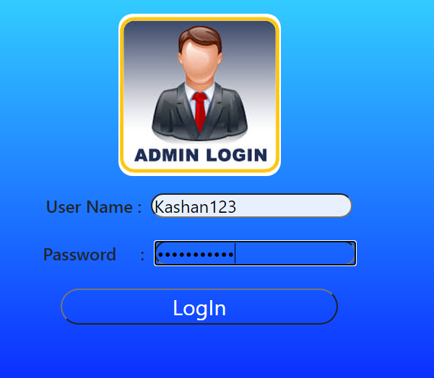

1. This is Admin login page.

2. Admin can access all details in Inquest.

**CODE**

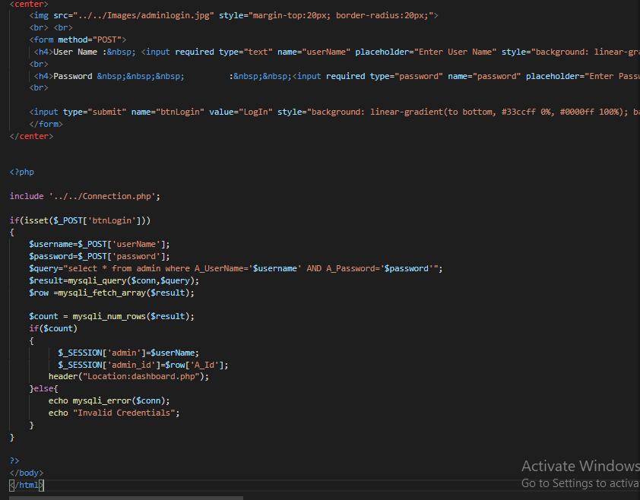

**ADMIN DASHBOARD**

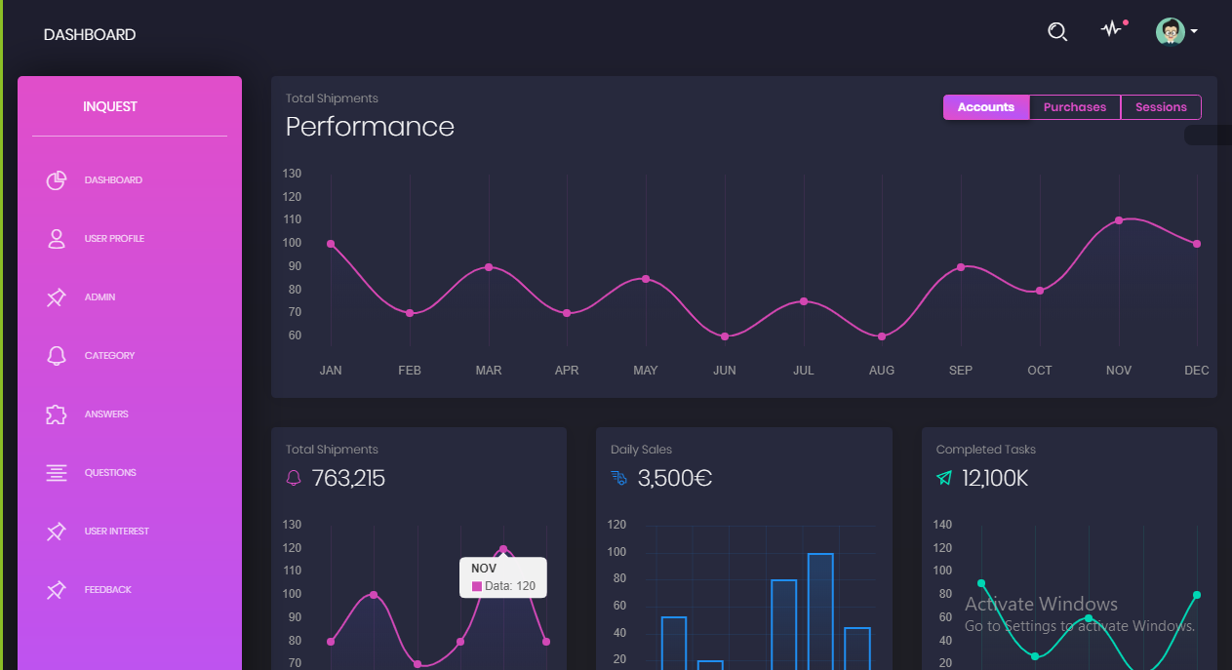

1. This is our Admin Dashboard page, we used side nav bar in header, and it contains many options like User Profile, Admin, Category etc . On this page Admin can access all the details in Inquest.
2. **User Profile:** When we press on the user profile , the new file will open as name as user profile where the admin can view, update and delete user profile.
3. **Admin:** When we press on the Admin , the new file will open as name as admin where the admin can view all admins, add new adin and update, delete Admin.
4. **Category:** When we press on the Category , the new file will open where the admin can add, update and delete category.
5. **Answers:** When we press on the answers, the new file will open where the admin can update and delete user answers.
6. **Questions:** When we press on the questions, the new file will open where the admin can update and delete user questions.
7. **User Feedback:** When we press on the feedback, the new file will open where the admin can update and delete user feedback.
8. Logout button took admin to the login page.

**CODE**

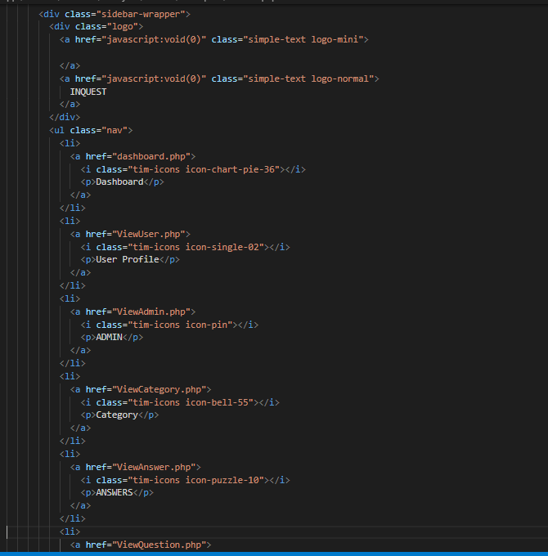

**USER DETAILS**

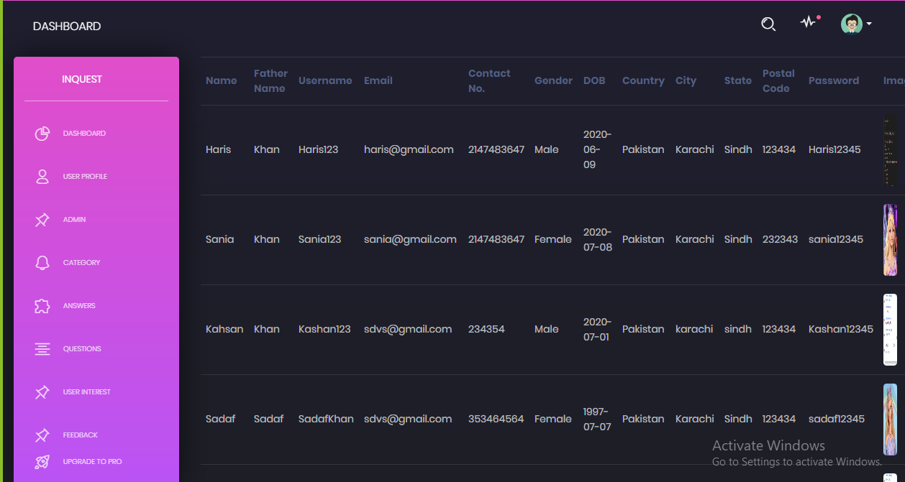

* This is our User Details Page.
* Admin can View User all details
* Admin can Update user details
* Admin can delete users

**CODE**

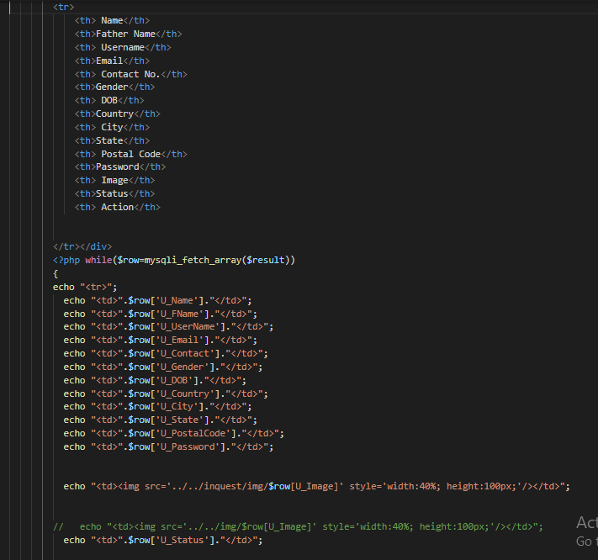

**ADMIN DETAILS**

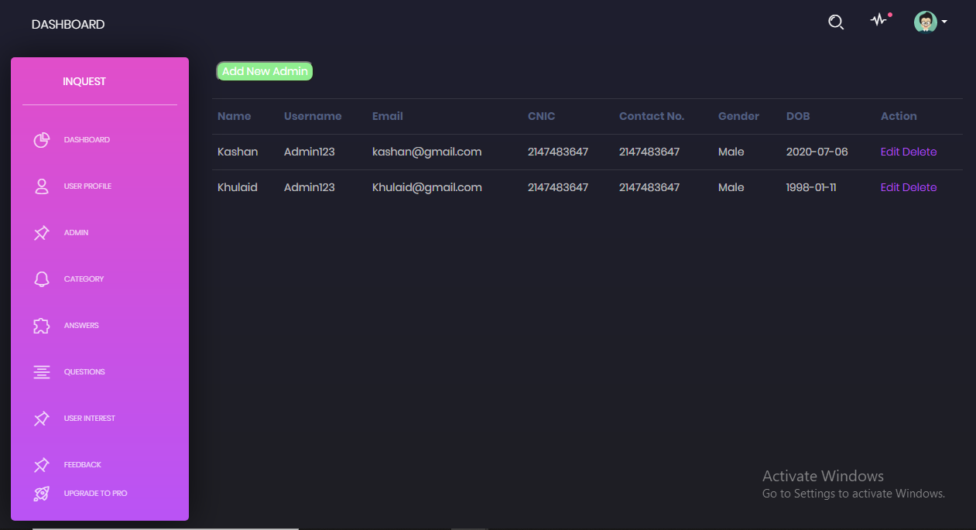

* This is our Admin details page
* Admin can View all Admin details
* Admin can Add new Admin
* Admin can Update Admin
* Admin can Delete Admin

**CODE**

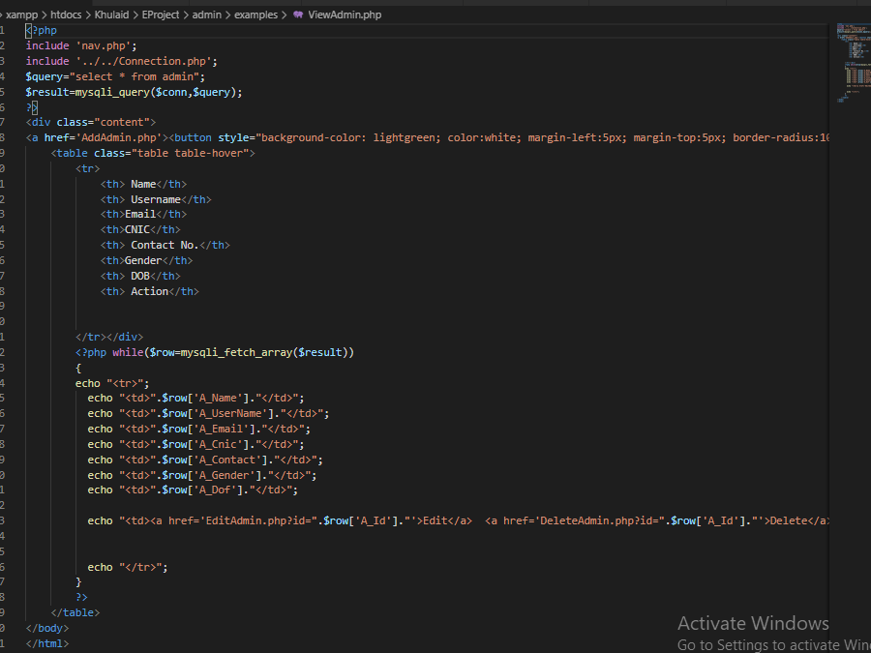

**CATEGORY DETAILS**

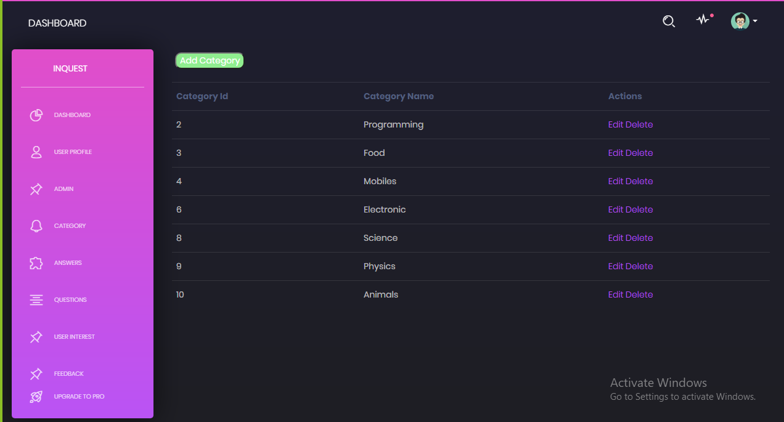

* This is our Category Details Page.
* Admin can View Category
* Admin can Add Category
* Admin can Update Category

**CODE**

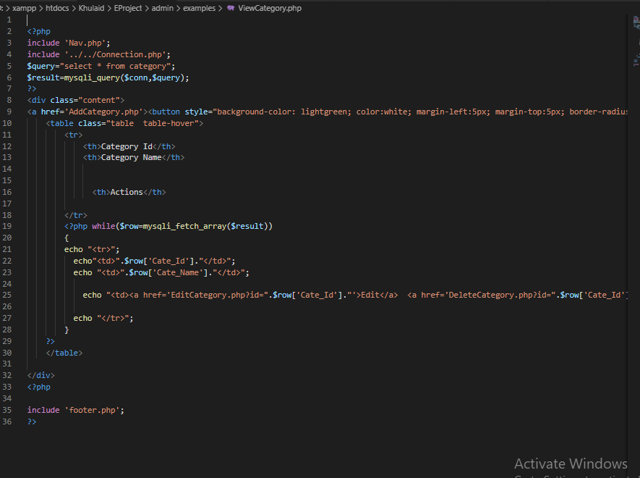

**ANSWERS DETAILS**

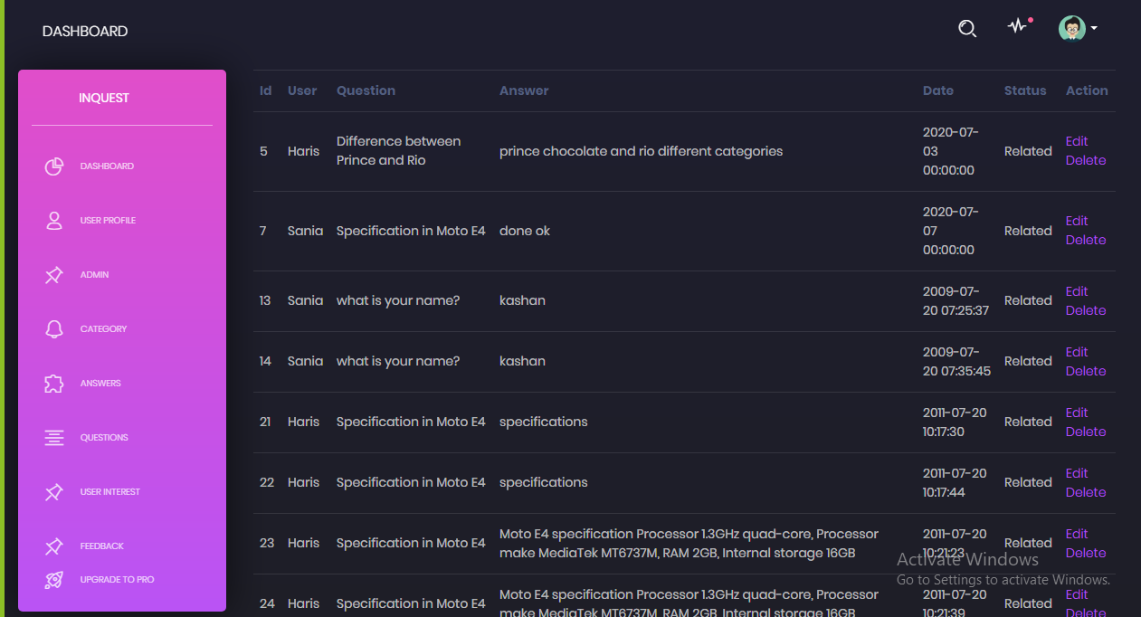

* This is our Answer details page
* Admin can View all Answers
* Admin can Update Answer
* Admin can Delete Answer

**CODE**

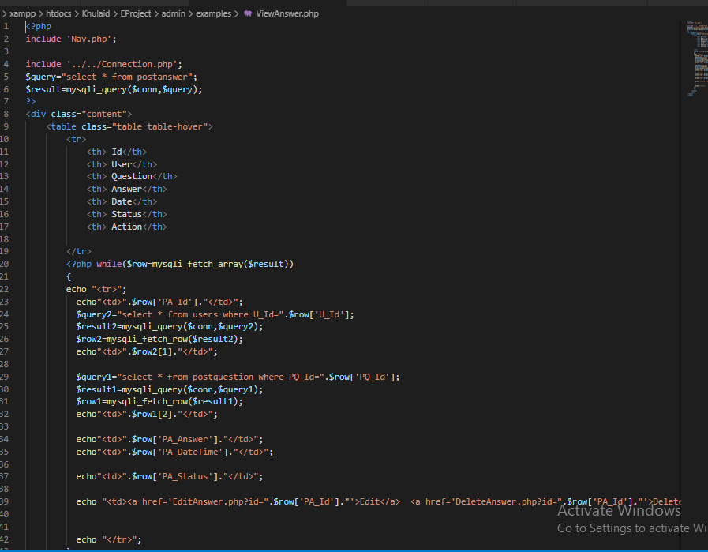

**QUESTION DETAILS**

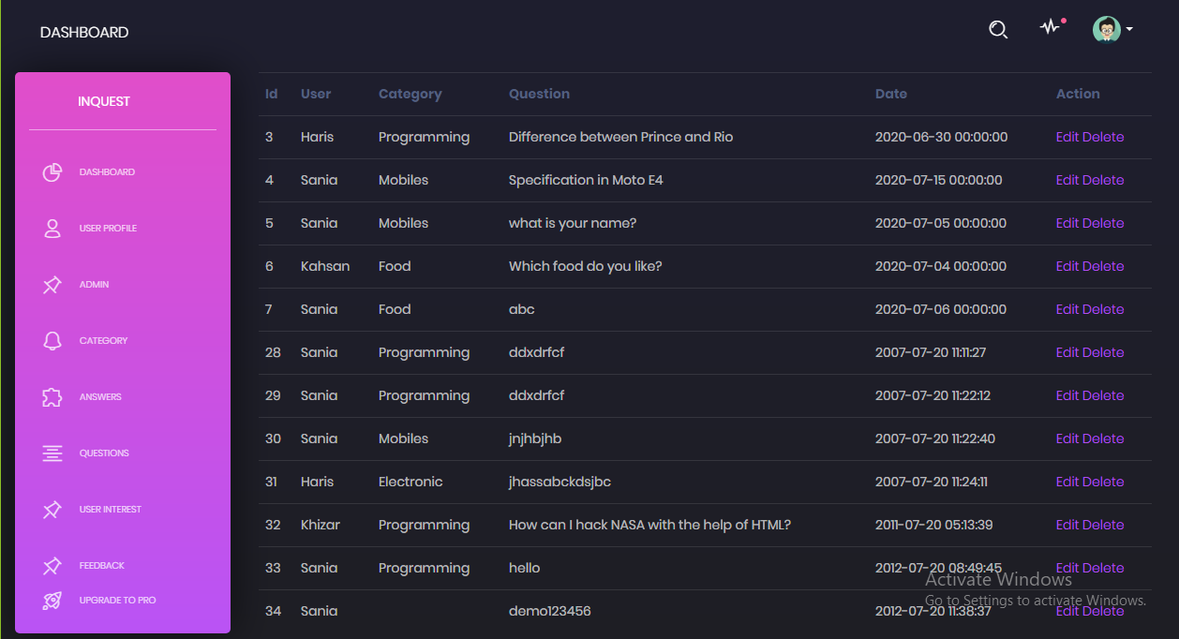

* This is our Question details page
* Admin can View all Questions
* Admin can Update Question
* Admin can Delete Question

**CODE**

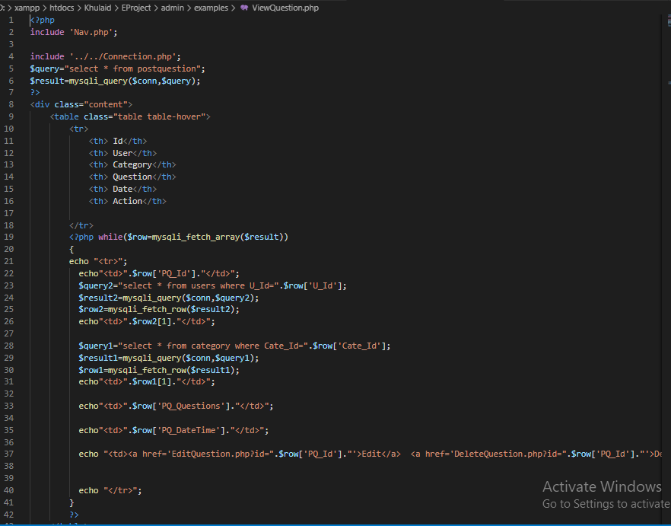

**USER FEEDBACK**

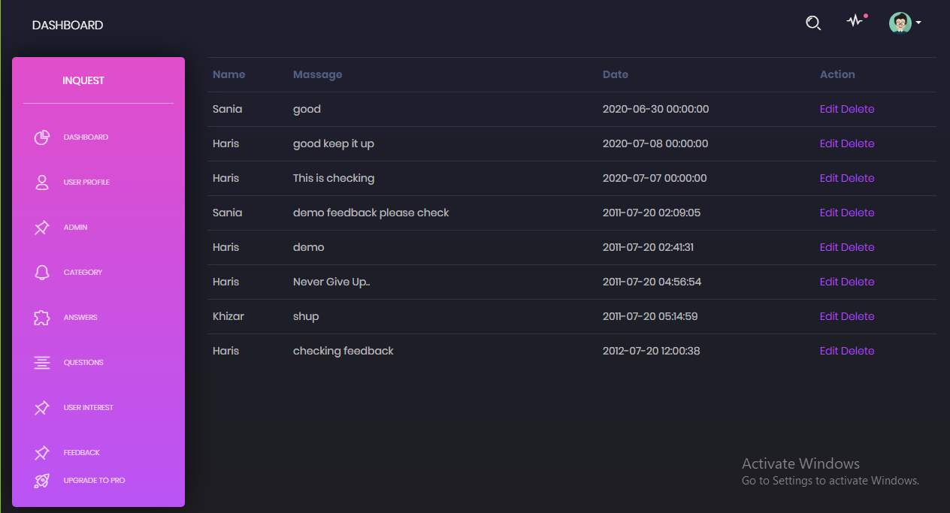

* This is our User Feedback page
* Admin can View all Feedbacks
* Admin can Update Feedback
* Admin can Delete Feedback

**CODE**

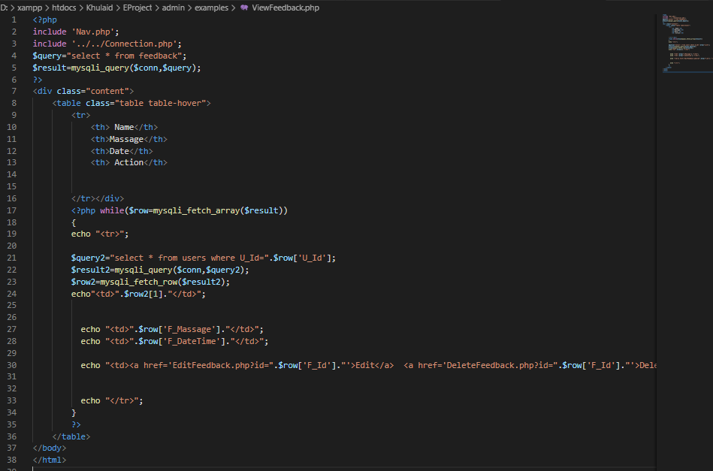

**USER INTERFACE**

**LOGIN AREA**

**LOGIN**

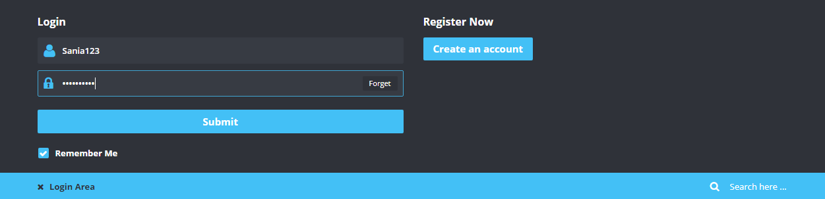

* This is our Login Area
* When you login from User you will able to access User Panel.
* When you click Create an Account.

**CODE**

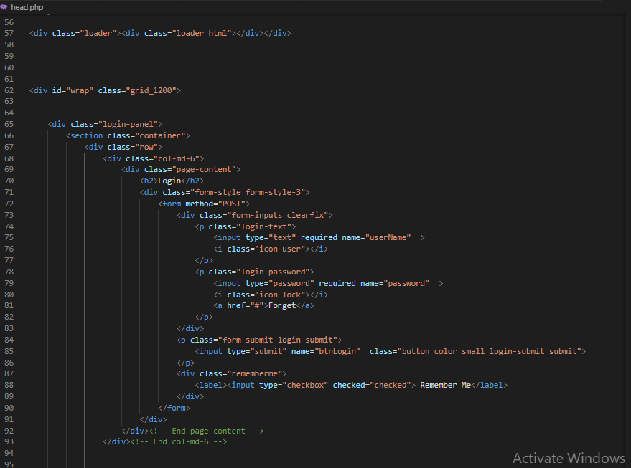

**REGISTRATION FORM**

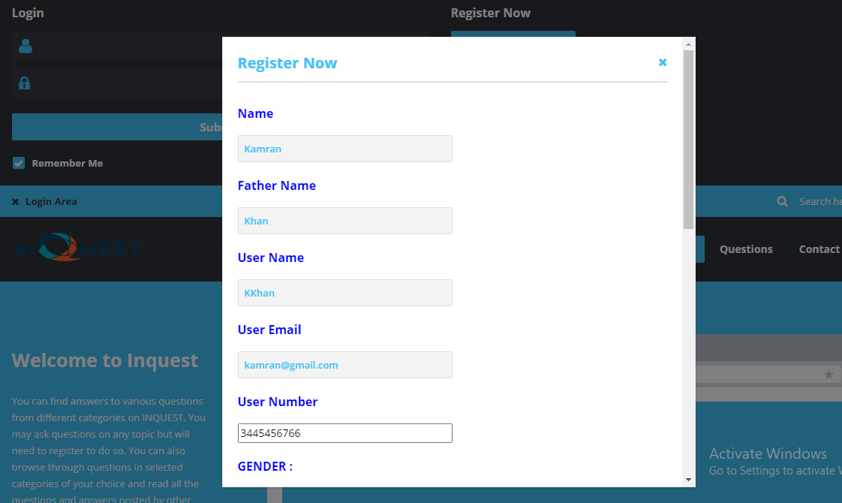

* This is Registration Form.
* User can create an account to fill this form.

**CODE**

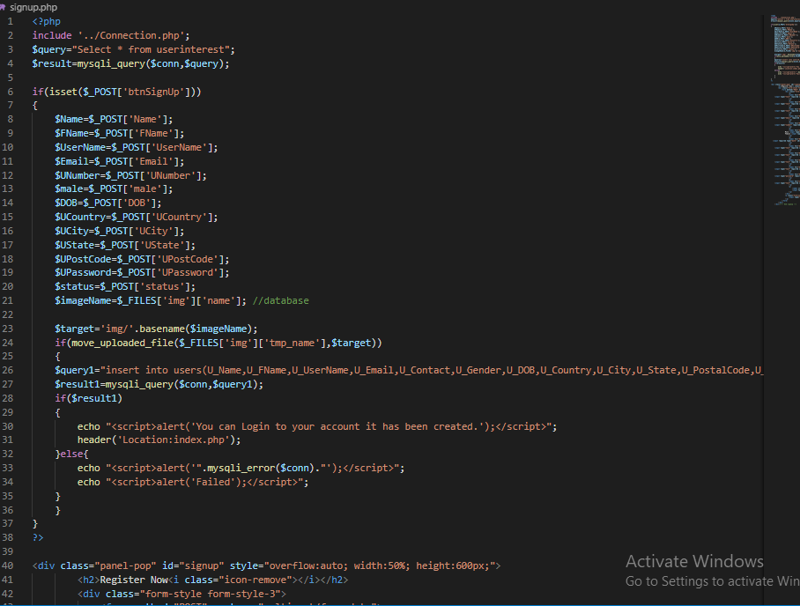

**HOME PAGE**

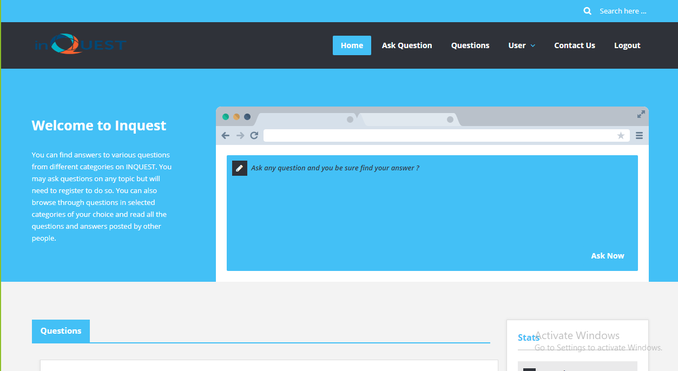

* This is our Home page.
* After login user can access many options
* User ask questions
* User view questions and reply all questions
* User see thier profile
* User can update their profile
* User can see our Contact information and give Feedback
* User want to logout so just clicking Logout Button.

**CODE**

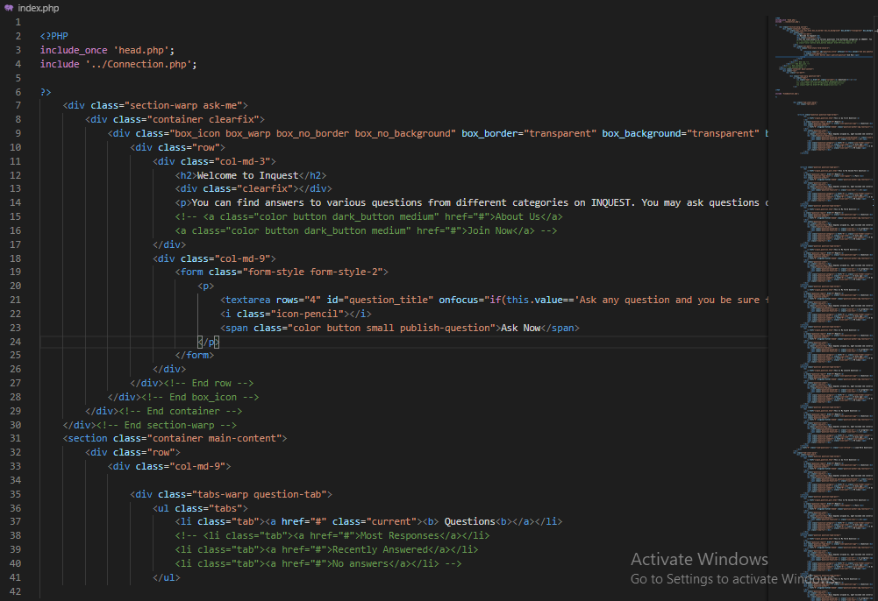

**ASK QUESTION**

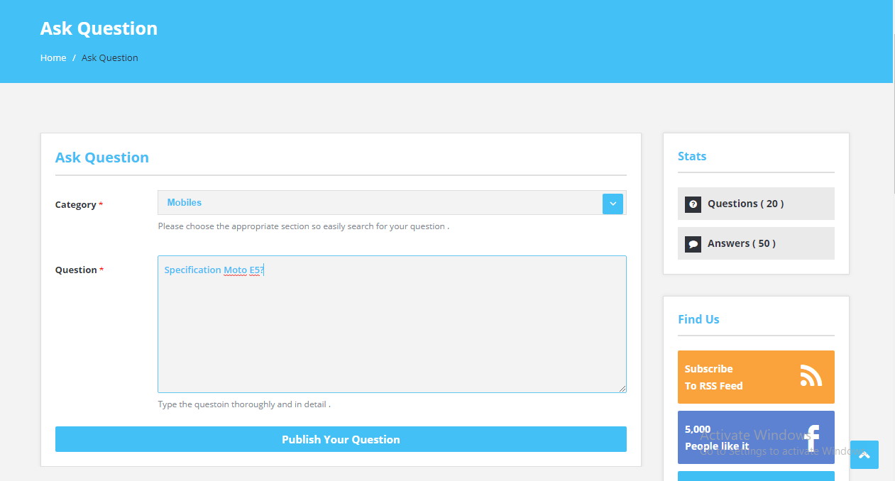

* This is our Ask Question page.
* User select category and than ask question according to category.

**CODE**

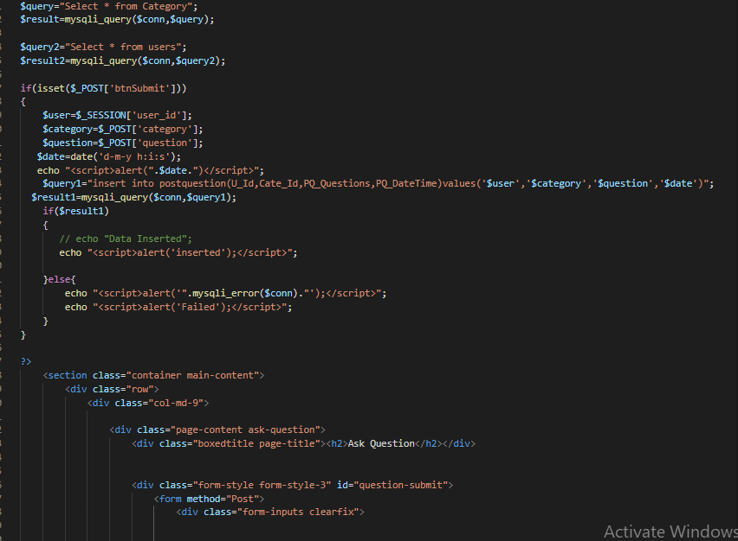

**View Question**

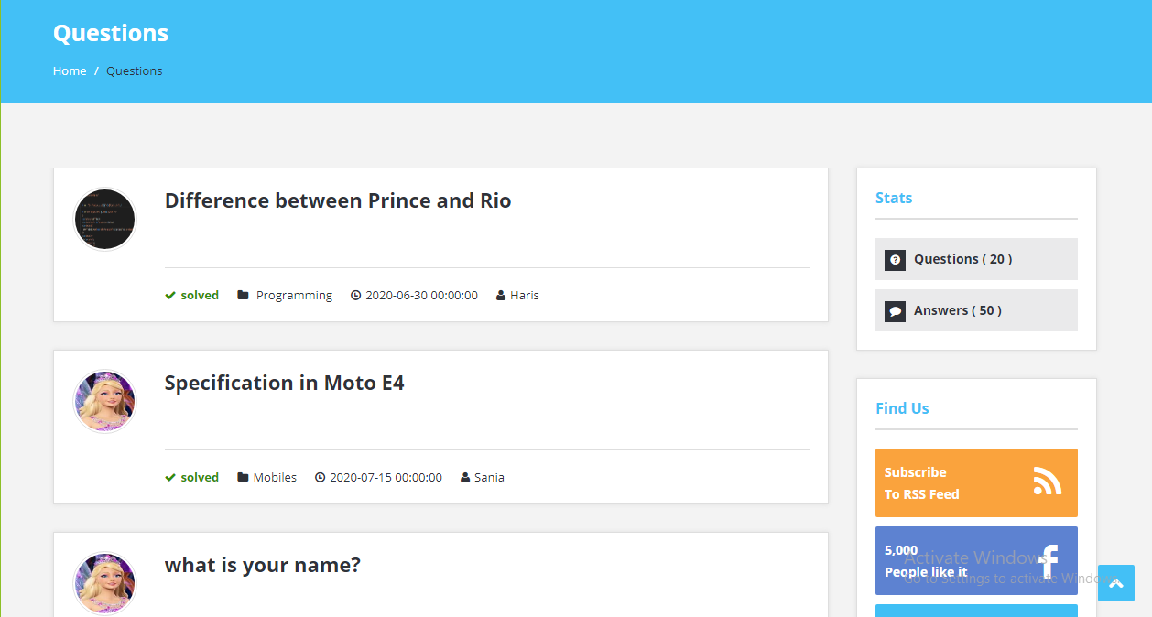

* This is our View Question page
* User can view all question to this page
* User select question to view answers selective question.

**CODE**

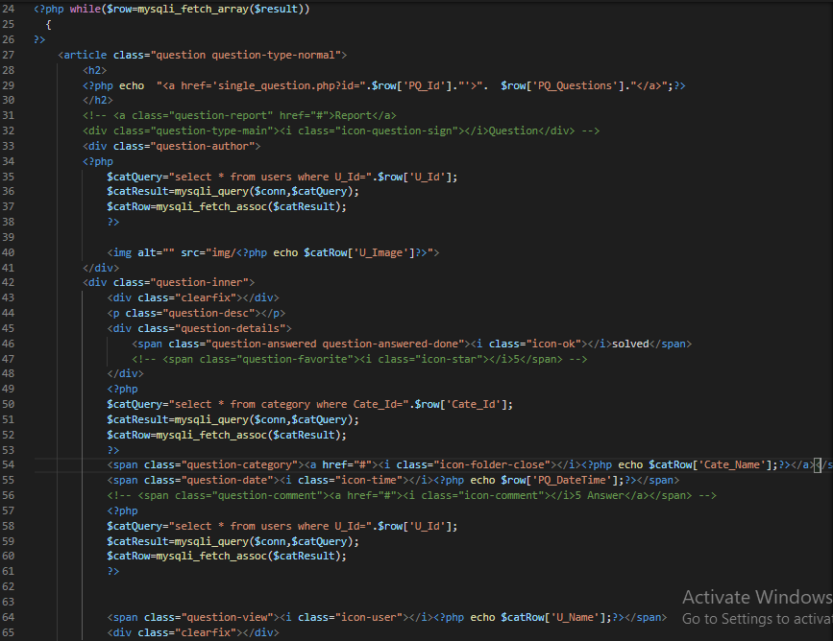

**ANSWERS**

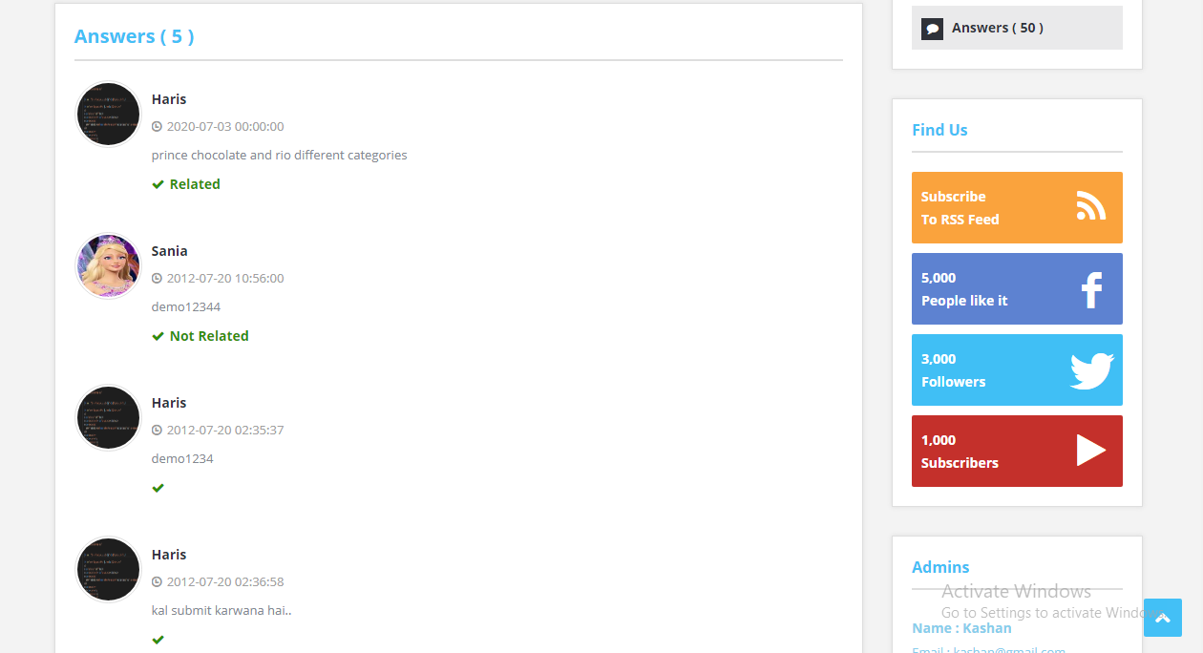

* This is our Answers page.
* User select question than move to this page.

**CODE**

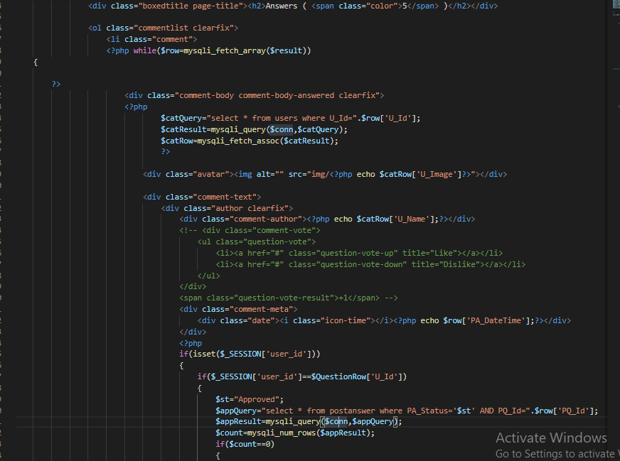

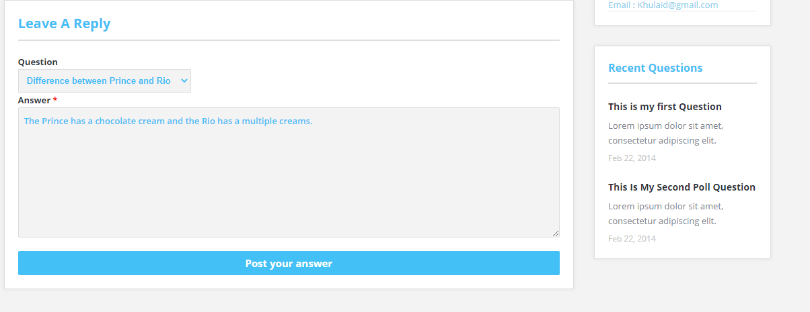

* This form also a part of Answer page
* User can give answer by this form.

**CODE**

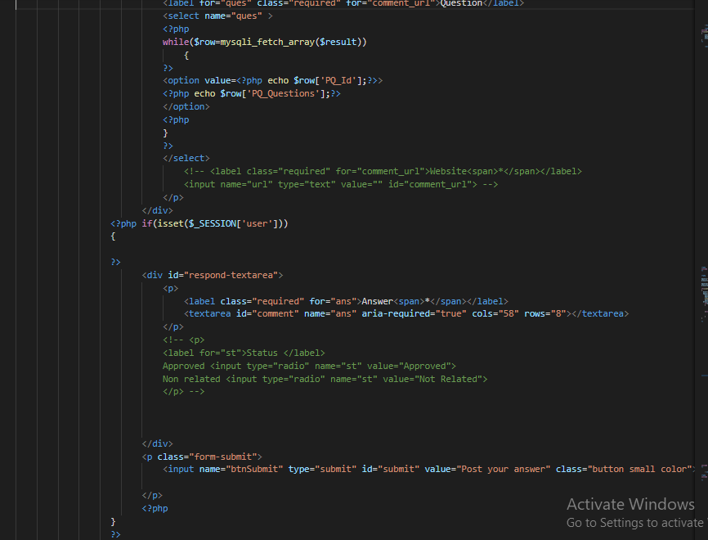

**USER PROFILE**

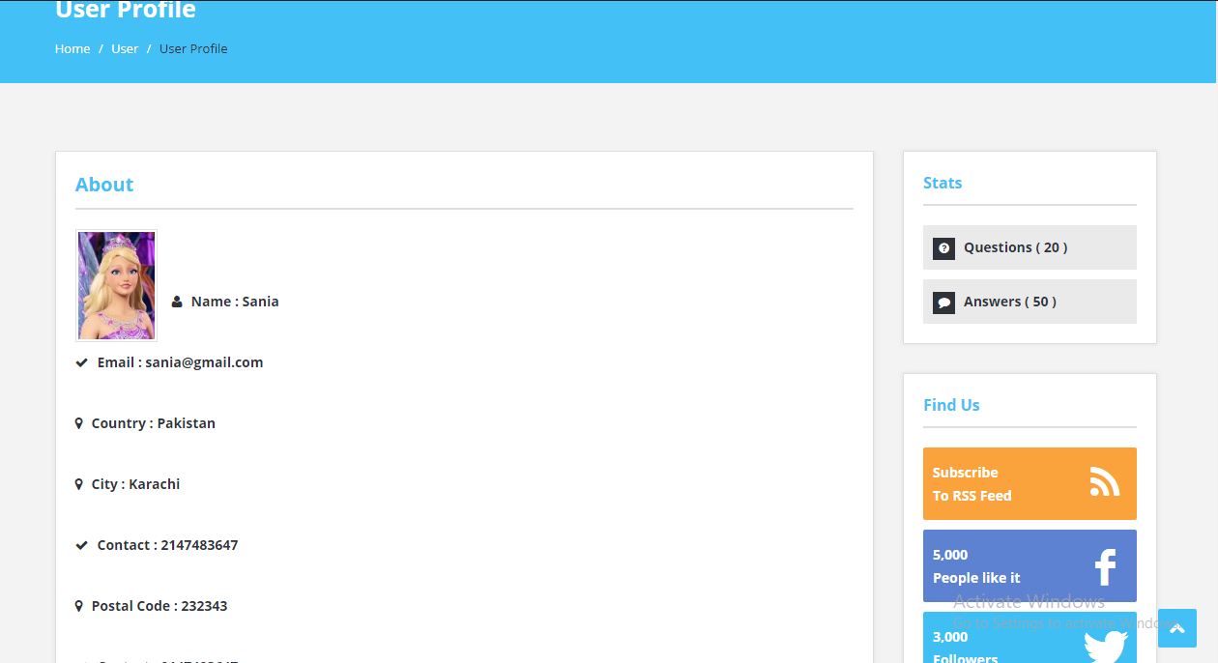

* This is our User Profile page
* User can view their profile to this page

**CODE**

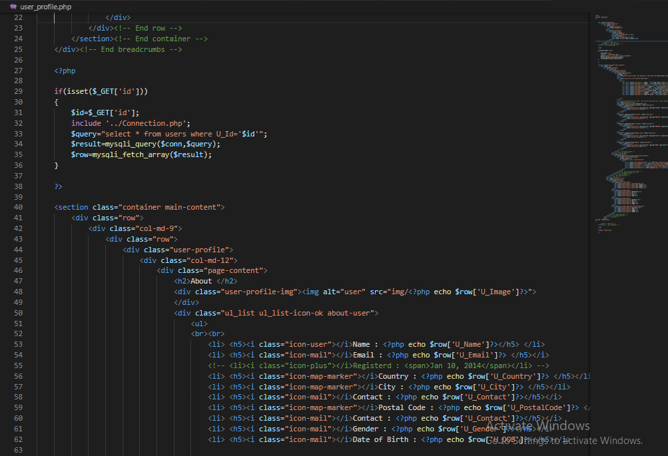

**USER PROFILE UPDATE**

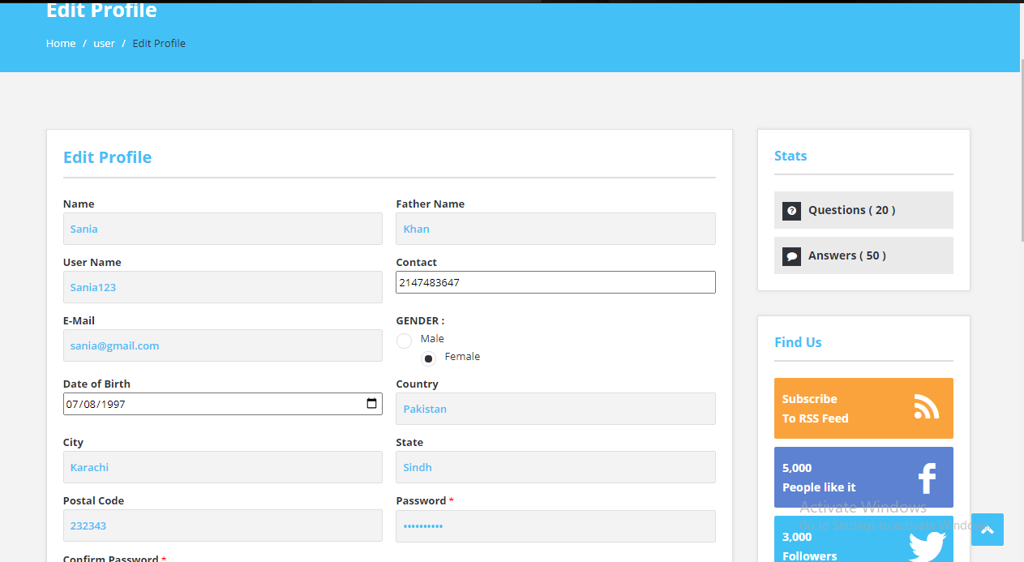

* This is our User Edit Profile page
* User can Edit their profile

**CODE**

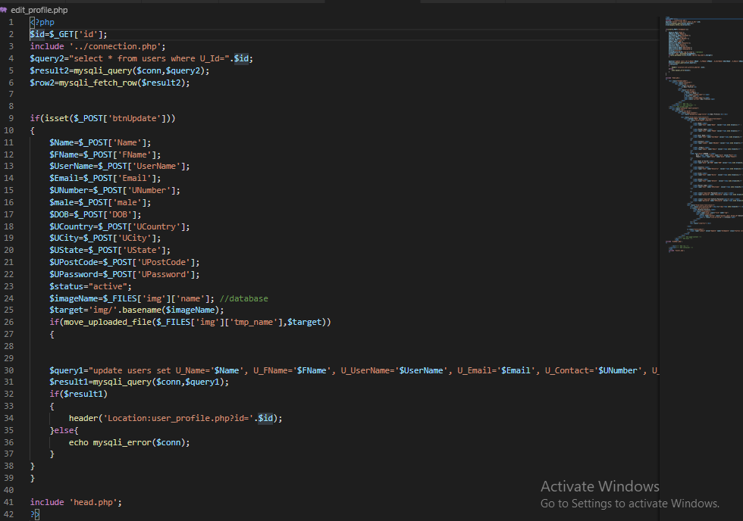

**USER FEEDBACKS**

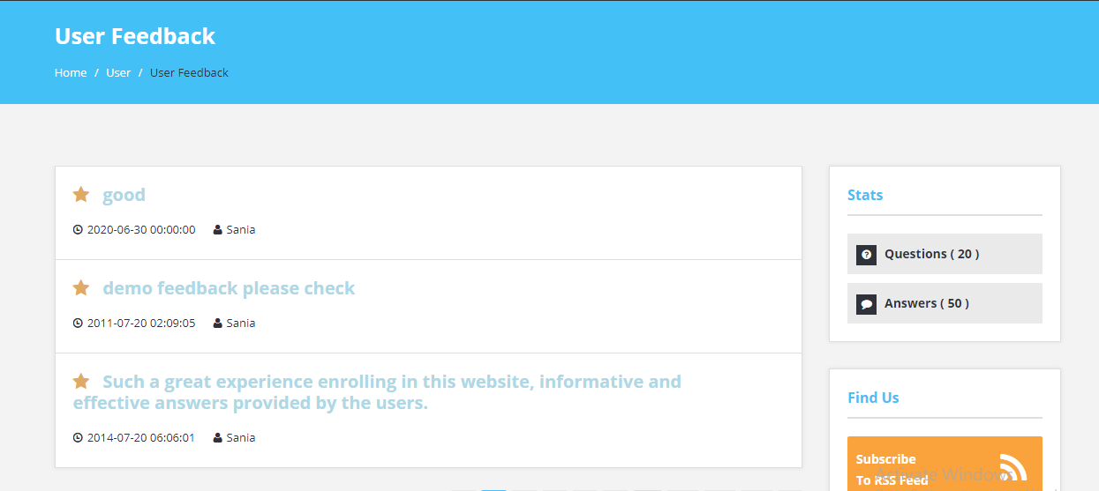

* This is our User Feedback page
* User can View their Feedback

**CODE**

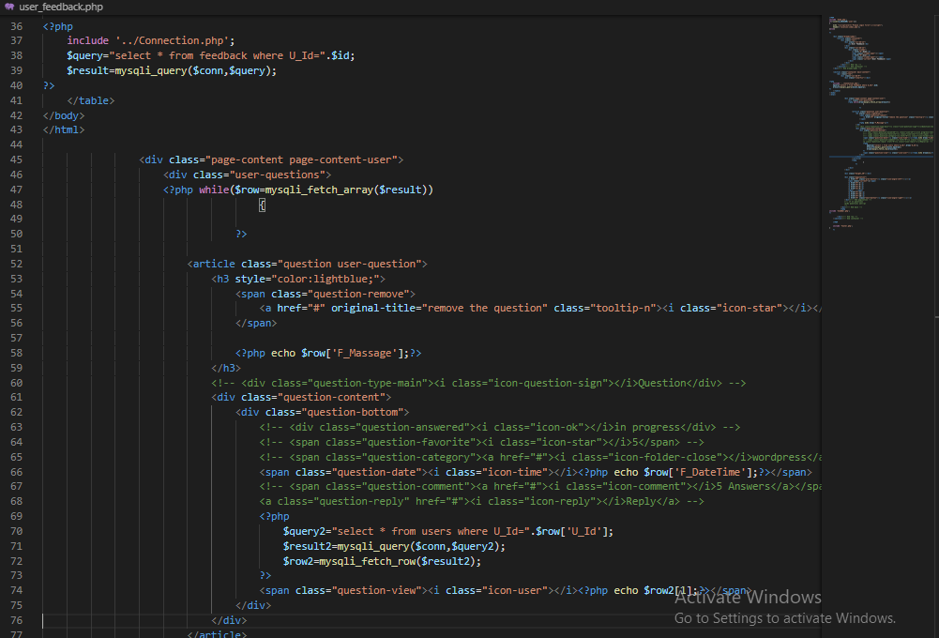

**FEEDBACK**

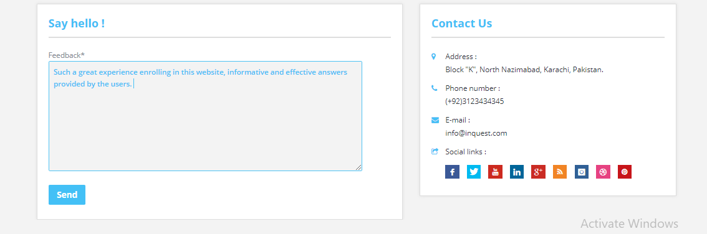

* This is our Feedback form
* It is compulsory to login our website to give feedback
* User can give Feedback by this form.

**CODE**

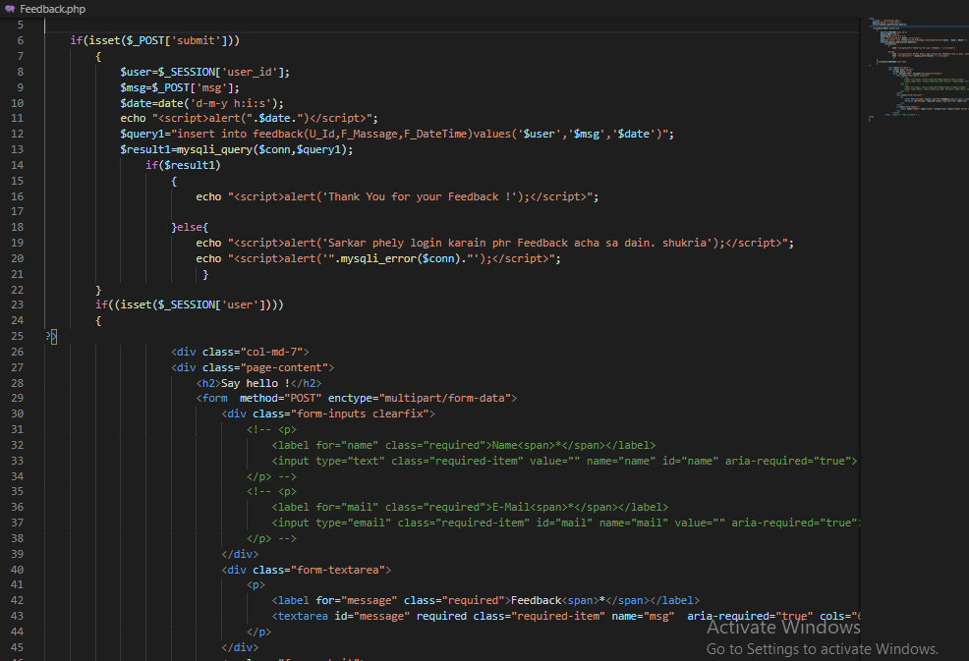

**CONTACT US**

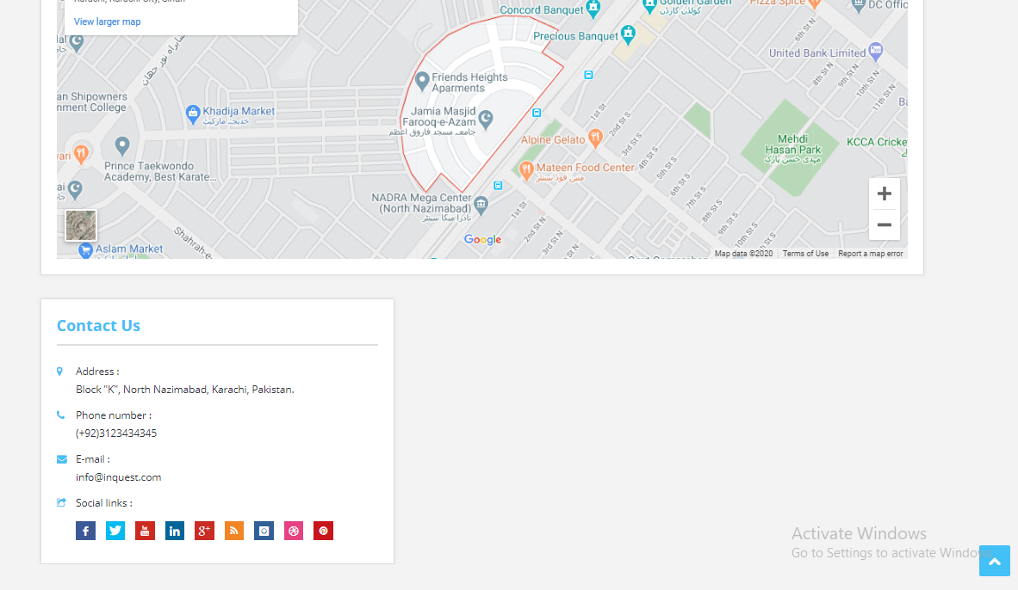

* This is our Contact page
* User find us through map location
* Contact us through Mail and Phone Number

**CODE**

